LAB 13
String & Date Functions

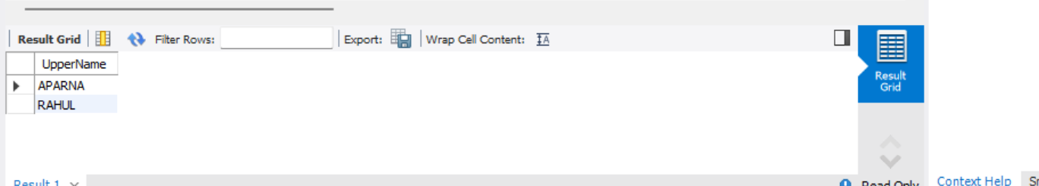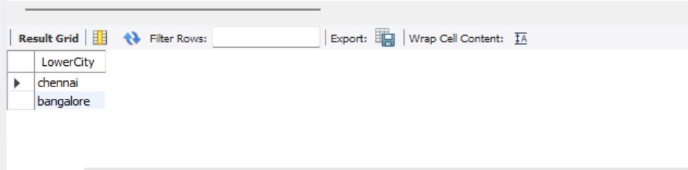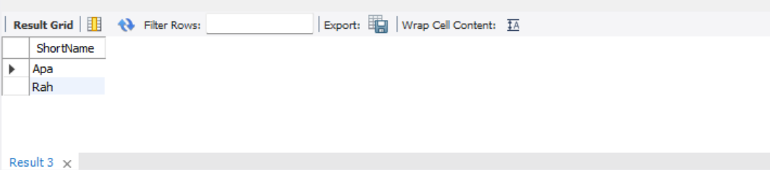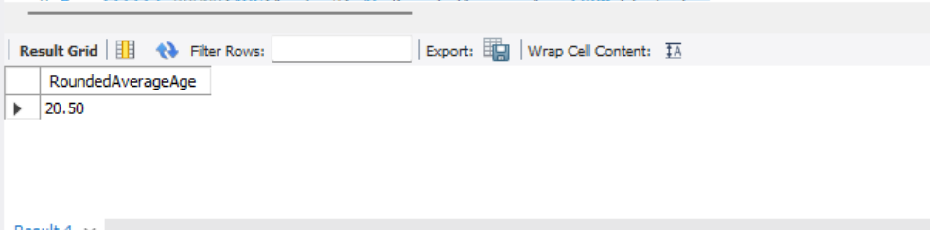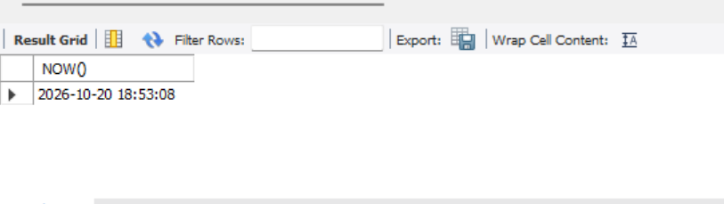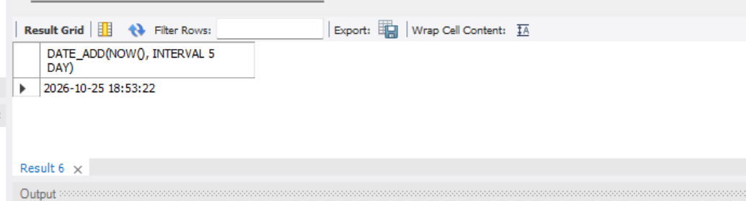
1. UPPER(): Converts all student names into uppercase letters.
2. LOWER(): Converts all city names into lowercase letters.
3. SUBSTR(): Extracts the first three characters from each student’s name.
4. ROUND(): Calculates the average age of students and rounds it to two decimal places.
5. NOW(): Displays the current date and time.
6. DATE_ADD(): Displays the date and time five days from now.

